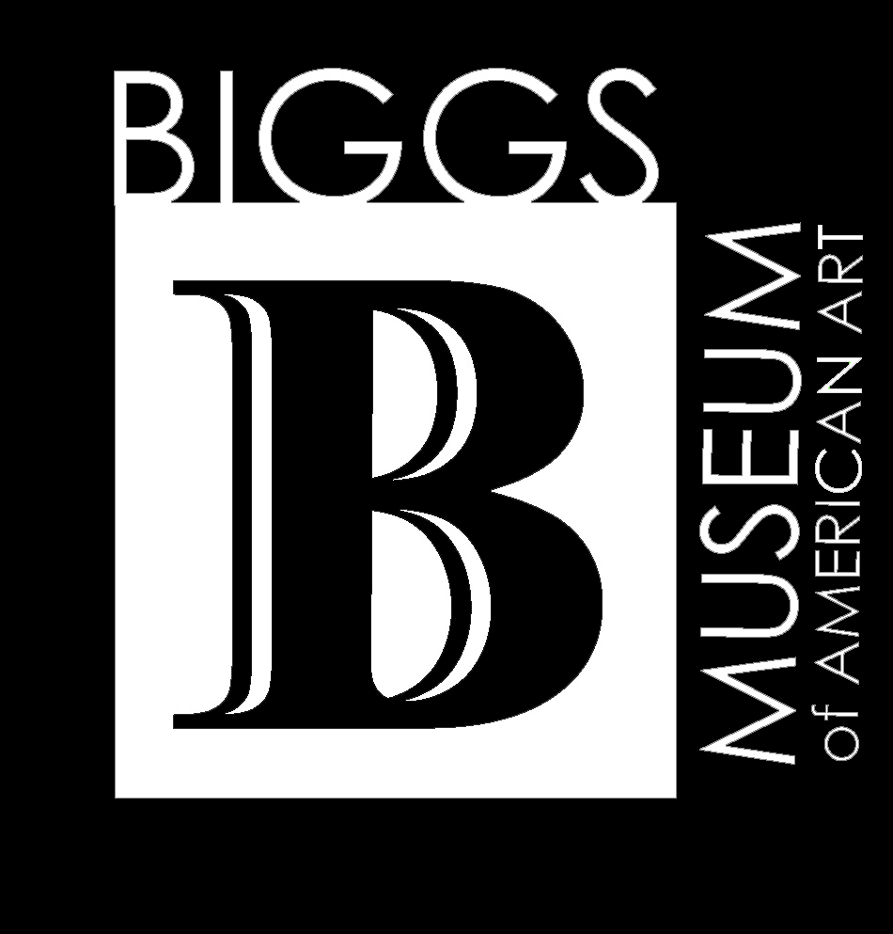

BIGGS SHOT: Juried Photography Exhibition
November 9, 2005 to February 26, 2006

Showcasing works by artists living and working in the
Greater Delmarva Peninsula

This is an opportunity for photographers, both amateur and professional, to exhibit their work in one of Delaware’s premier art museums. The Biggs museum, centrally located on the peninsula, specializes in fine and decorative arts made and used in Delaware and the Mid-Atlantic region from 1700 to the present. The museum showcases several changing exhibitions of contemporary and historical significance every year.
Neighborhood museum – National treasure

Project Calendar:
Applications due ongoing till October 12, 2005
Objects delivered to museum October 10-12, 10am-4pm
Jury selection October 13
Jury notification mailed October 18
Return of works not chosen October 26-28
Exhibition opens November 9
Opening reception November 9, 5:30-8:30pm
Exhibition closes February 26, 2006
Return of unsold works March 1-3

Jurors:
Katherine Ware is Curator of Photographs at the world famous Philadelphia Museum of Art.
Sally S. Packard & Dinah G. Reath are Directors of the only fine art photography gallery in Delaware and the Delmarva peninsula, the Packard Reath Gallery of Lewes, Delaware.

Artist’s eligibility and museum’s conditions:
This competition is open to all photographers. The maximum dimension (including frame) should not exceed 40 inches in any direction. Iris or Giclee entries are acceptable. All works must be presented professionally, secured with apparatus to hang, and be clearly identified on the back only. If works are for sale, the price must also be clearly identified on the back. The Biggs Museum retains a 25% commission on all works sold in the galleries and issue checks after the exhibition closes. The Biggs Museum will insure the works against theft, damage, and loss. All artists must submit an entry form up till October 12 and be willing to deliver their works to the Biggs Museum between October 10 and 12. All applications must be accompanied by a $25 non-refundable fee payable by cash, check or money order to the “Biggs Museum.” The fee covers the vetting process of up to three works – an additional $5 will be charged for each additional work. Works not accepted for the exhibition must be returned between October 26 and 28, 2005; unsold works accepted into exhibition must be returned between March 1 and 3, 2006.

What to do:
- Send in this application form with a minimum $25 fee to:
Biggs Museum of American Art
Attn: Ryan Grover, Curator
PO Box 711
Dover, DE 19903

- Bring your works to the Biggs Museum between 10am and 4pm, October 10 through October 12.
Second Floor
406 Federal Street
Dover, DE 19903

Exhibition opening reception:
This exhibition will open with a catered public reception honoring the accepted artists of the competition on November 9, 2005 – 5:30-8:30pm at the Biggs Museum of American Art located on the second floor of 406 Federal Street, Dover, Delaware. The museum will print invitations for its mailing list. Accepted artists are encouraged to submit up to 25 additional names with contact information of individuals living within a one-hour radius of the museum; extra invitations can be printed at a fee to be determined. Reception ticket prices are $15/$10 members and accepted artists come for free.

BIGGS SHOT: ARTIST APPLICATION &

AGREEMENT FOR INCOMING LOAN

Lender:
Telephone: E-mail:
Address:

In accordance with the conditions printed on this document, the object(s) listed below are borrowed for the following purpose: jury selection/exhibition

Title of exhibition: Biggs Shot
Object(s) is/are borrowed for the period from: October 10, 2005 to October 28 or March 3, 2006

Size Description / Title Value
$
$
$
$

Shipping/Transport

The object(s) will be transported by lender, delivered on the date of: October 10-12, 2005

The object(s) will be returned to the lender by the date of: October 26-28, 2005 or March 1-3, 2006

Insurance:
X to be carried by the Museum; send certificate of insurance;
to be carried by the Lender; insurance waived.

Credit Line for exhibition labels: Courtesy of

Lender’s permission to reproduce image of object for publication: Y N

I have read and agree to the conditions above and on the reverse of this document and certify that I have full authority to enter into this agreement.

Lender's signature: Date:

Approved For the Biggs Museum:

Signed: ____________________________________________; Curator Date:

Mail to:
Biggs Museum of American Art
Attn: Ryan Grover, Curator
PO Box 711
Dover, DE 19903

